Data Transformation Process for Event Data Warehouse.

Table of Contents

Introduction 2

Step 0: Get Data Into the Standard Format 2

Input Data Structure 2

Data Map 2

SQL 3

Description of the MyLyn Map 5

Overview of CANS WAREHOUSE Data Flow and Transformation Processes 6

Extract Distinct Reference Points 6

Explode Relational Data 10

Create Dimension Records From Reference Tables 13

Create Final Fact Table 13

An example of full execution of the physical import process using data imported from the new, Oracle version of the CANS tables 14

Following the Procedures 15

References 15

# Introduction

This is a fifteen or sixteen step data transformation process. Give or take.

# Step 0: Get Data Into the Standard Format

We begin with step 0, which is getting the data from a source system into the required input format. For example, data from the MyLyn system was in this format:

## Input Data Structure

## Picture 38.png

## Data Map

We created a map to move the data from that format, to the following format:

The first explosion covers people who comment on a bug. This map creates a relationship between people commenting on a bug, and the person who is assigned that bug.

Table - MyLyn - Data map for explosion one

|  |  |  |
| --- | --- | --- |
| **First Explosion** |  |  |
| Events\_Stage Field | mylyn.research\_comments\_by\_release field | Type |
|  |  |  |
| ID | autoincrement or create | generate |
| Environement\_code | Bugzilla | literal |
| context\_name | Mylyn | literal |
| context\_id | MyLyn | map |
| context\_type | Software Engineering | literal |
| event\_ip | 0 | literal |
| event\_session | research\_comment\_by\_release.releaseid | map |
| event\_action | jforum.new | literal |
| event\_object | research\_comment\_by\_release.short\_desc | map |
| event\_url | research\_comment\_by\_release.bug\_id | map |
| event\_author\_id | research\_comment\_by\_release.author\_id | map |
| event\_author\_name | n/a | literal |
| event\_date | research\_comment\_by\_release.commentTS | map |
| object\_creator | research\_comment\_by\_release.assigned\_id | map |

The second explosion, in this case, covers people who were the original bug creators, and subsequently creates a connection between those creators and the people commenting on the bug.

Table - MyLyn, Data map for explosion two

|  |  |  |
| --- | --- | --- |
| **Second Explosion** |  |  |
| Events\_Stage Field | mylyn.research\_comments\_by\_release field |  |
|  |  |  |
| ID | autoincrement or create | generate |
| Environement\_code | Bugzilla | literal |
| context\_name | MyLyn | literal |
| context\_id | MyLyn | map |
| context\_type | Software Engineering | literal |
| event\_ip | 0 | literal |
| event\_session | research\_comment\_by\_release.releaseid | map |
| event\_action | jforum.read | literal |
| event\_object | research\_comment\_by\_release.short\_desc | map |
| event\_url | research\_comment\_by\_release.bug\_id | map |
| event\_author\_id | research\_comment\_by\_release.author\_id | map |
| event\_author\_name | n/a | literal |
| event\_date | research\_comment\_by\_release.commentTS | map |
| object\_creator | research\_comment\_by\_release.reporter\_id | map |

## SQL

This SQL is used to move the data from the Mylyn database table to the tables in the CANS\_Warehouse..

[9/9/10 9:09:11 AM] Michael Gallagher:

Table - Mylyn, data mapping into warehouse structure SQL

|  |
| --- |
| Step 1:  insert into cans\_warehouse.events\_stage\_mylyn(environment\_code,           context\_id,           context\_name,           context\_type,           event\_ip,           event\_session,           event\_action,           event\_object,           event\_url,           event\_author\_id,           event\_author\_name,           event\_author\_city,           event\_author\_state,           event\_author\_zip\_code,           event\_author\_country,           event\_author\_latitude,           event\_author\_longitude,           event\_date,           event\_object\_type,           object\_creator,           weight\_in\_minutes,           row\_type,           parent\_id)  select 'bugzilla',’mylyn’,'mylyn','Software Engineering',  '0',mylyn.research\_comment\_by\_release.releaseid,'jforum.new',  mylyn.research\_comment\_by\_release.short\_desc,mylyn.research\_comment\_by\_release.bug\_id,  mylyn.research\_comment\_by\_release.author\_id,' ',' ',' ',' ',' ',' ',' ',  mylyn.research\_comment\_by\_release.commentts,' ',mylyn.research\_comment\_by\_release.assigned\_id,  ' ',' ',' '  from mylyn.research\_comment\_by\_release  Step 2:  insert into cans\_warehouse.events\_stage\_mylyn(environment\_code,           context\_id,           context\_name,           context\_type,           event\_ip,           event\_session,           event\_action,           event\_object,           event\_url,           event\_author\_id,           event\_author\_name,           event\_author\_city,           event\_author\_state,           event\_author\_zip\_code,           event\_author\_country,           event\_author\_latitude,           event\_author\_longitude,           event\_date,           event\_object\_type,           object\_creator,           weight\_in\_minutes,           row\_type,           parent\_id)  select 'bugzilla',’mylyn’,'mylyn','Software Engineering',  '0',mylyn.research\_comment\_by\_release.releaseid,'jforum.read',  mylyn.research\_comment\_by\_release.short\_desc,mylyn.research\_comment\_by\_release.bug\_id,  mylyn.research\_comment\_by\_release.author\_id,' ',' ',' ',' ',' ',' ',' ',  mylyn.research\_comment\_by\_release.commentts,' ',mylyn.research\_comment\_by\_release.reporter\_id,  ' ',' ',' '  from mylyn.research\_comment\_by\_release |

## Description of the MyLyn Map

The Mylyn data differs from CANS data in one important way – there are two types of object creators, and the map between the event author and the object creator is already in the file. We don’t need to go get it. The data is also less rich than CANS data, because we do not get an event each time something is read. You can see from the map above that we refer to the connection between the bug creator and the bug commenter as a “read” connection. This approximates the same concept of a “read” in CANS.

The data is now in the warehouse table “Events\_Stage”:

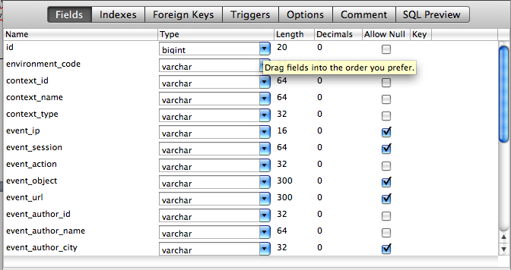

At this point the data that is being brought in, begins the procedural part written for CANS data.

The figure, below, lists the items that change for each load procedure. Mike’s next goal is to handle deletion of dimension data better when a load fails. Also, there are two data sets that remain to be loaded.

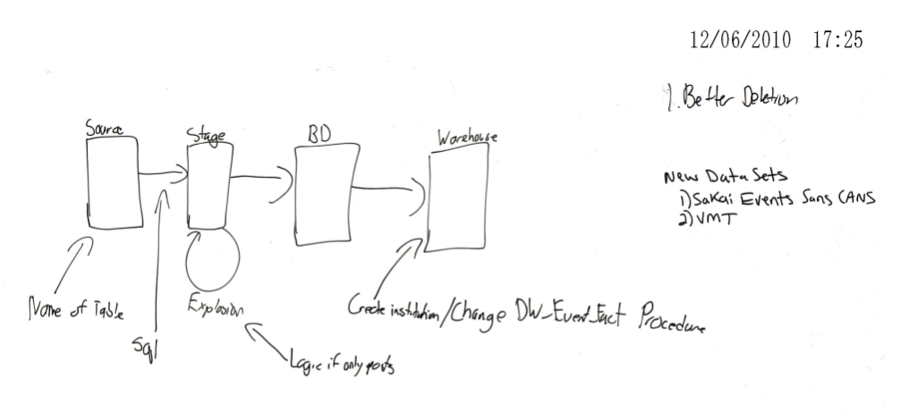

Figure - Overview of what changes during loads of different data

# Overview of CANS WAREHOUSE Data Flow and Transformation Processes

Figure one provides a conceptual overview of all of the steps to follow. First, we get events from source, which is already described in the first part of “Step 0”. Second, data is moved to the staging area, which for now, is simply the “EVENTS STAGE” table, also described in step 0.

## Extract Distinct Reference Points

When we go to “Extract Distinct Reference Points”, we are extracting the data into a set of “BD” tables (which is an acronym for the project code name, ‘Bucky Dome 2’. This step is about inventorying all of the components, about which we have event data. The “BD” tables are a staging area. They are truncated at the conclusion of every successful load process. The critical components are enumerated in the box. These are:

1. Context –
   1. Context ID – For example, with CANS, the context id is the course ID. The context ID for Bugzilla is “MyLyn”
   2. Context Name – For example, the context with CANS is “sakai” and for BugZilla it is “Bugzilla”
2. Context Type for Sakai is “Group” and for Bugzilla it is “Software Engineering”.
3. Event Action in Sakai is determined by CANS. We map Bugzilla events to jforum.new and jforum.read for now, as it makes subsequent analysis more consistent. In the future we should develop a more abstract name for these event types. Some of the logic to do this is in the procedures that reference the table “event\_action\_mapping”, but we have not fully tested this logic. This should be tested in the future; we think its done…

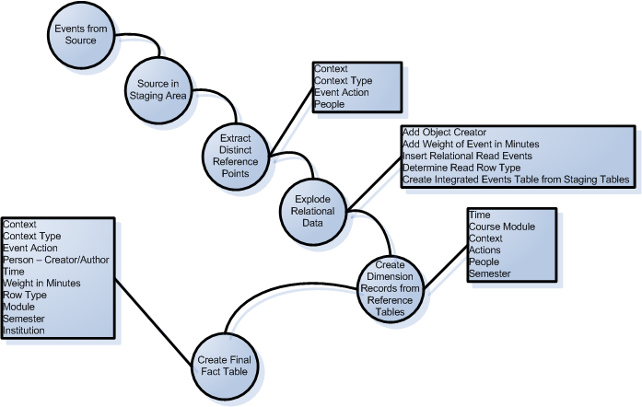

Figure - Overall Flow Diagram, Conceptual Level

Figure two shows “extract distinct reference points” as four procedures: Insert\_Context, Insert\_EventActions, Insert\_Persons\_withcreators, and Insert\_context\_type.

In the case of the MyLyn loading, which was our first attempt at loading a data set other than CANS, we took a careful, stepwise approach and did not run the “loading master program” that performs all steps automatically.

Table - SQL Used during the MyLyn Data Import

|  |
| --- |
| update events\_stage\_mylyn set context\_id = 'mylyn';  truncate table events\_stage;  truncate table bd\_context;  truncate table bd\_events;  delete from DW\_Events\_Fact where institution\_id=2; -- This deletes from previous runs in the fact table for MyLyn. We had to do this as we experimented with data. Ensuring that each data set has a distinct institution ID, or some group of data that we can use for this process is critical.  delete from DW\_Context\_Dim where DW\_Context\_Dim.Context\_name != 'sakai'; -- this is a similar function for deleting context during trial runs.  --Here, we see the events\_stage  insert into events\_stage  select \* from events\_stage\_mylyn;  ---Here, Mike is just redoing the necessary parts after an initial run. These parts had to be changed because we mapped the context wrong initially.  call insert\_context();  call insert\_into\_events\_stage();  call update\_rows\_for\_sna\_type();  call insert\_events\_withcreators();  call DW\_insert\_context\_dim();  call DW\_insert\_events\_fact(); |

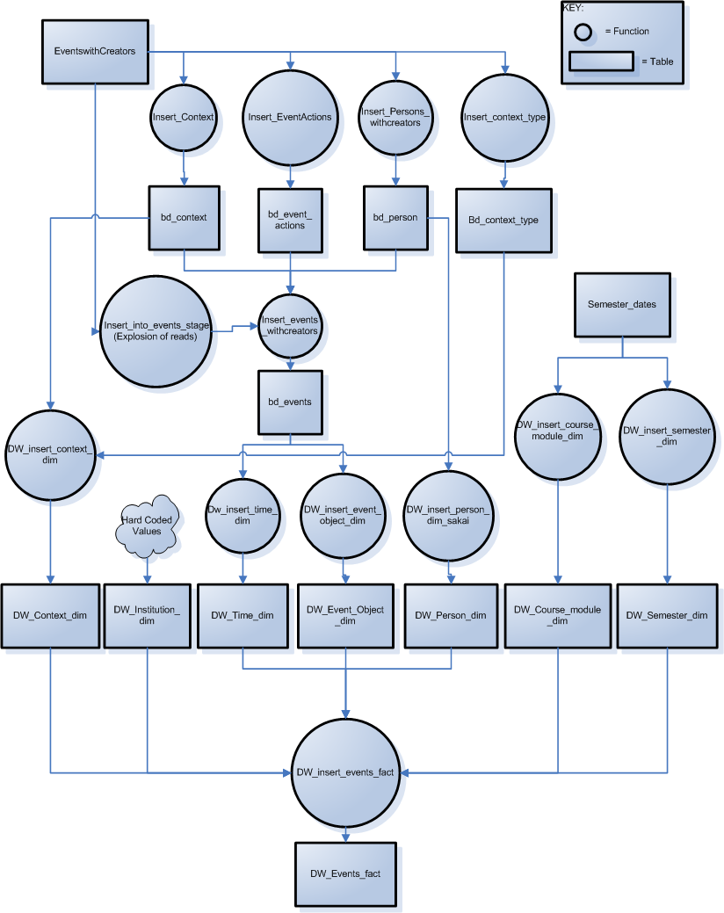

Figure - Technical Description of Procedures Executed

## Explode Relational Data

Conceptually, there are five main steps in this process: Add the object creator, add weights to the events based on minutes that transpired, inserting relational read events, determining the read row type and creating integrated events table from staging tables.

With “Add Object Creator” we are accounting for a shortcoming in the original CANS data set, where the person who created the object being read by the event author is not known. In CANS data, however, we can determine who created the object by looking at the object name, and searching for the original jforum.new event – the oldest event for that particular object. With reference to the CANS data, “event\_url” represents the object. There is a unique event\_url for each discussion board and resource. We did not need to do this in the MyLyn data because the original source data included the event\_object\_creator.

The presence or absence of an event\_object\_creator in the source data is important to understand, with reference to figure four. In figure four, we see the procedure insert\_into\_events\_stage is called. This procedure has two sources in the database: insert\_into\_events\_stage\_cans and insert\_into\_events\_stage\_mylyn. It is **vital** to make sure that the base procedure; insert\_into\_events\_stage is substituted with the appropriate procedure, depending on the nature of the source data. In the future, this logic should be handled as an input parameter.

Adding weights to each event in minutes incorporates traversing the original events from the “events\_stage” table and calculating the minutes between each read or post event and the prior read or post event in a sequence (discussion board). The cardinality of this data is the same as the original event data loaded from the source.

In the next step, we account for the fact that many reads and posts in CANS include reference, at least tacitly, to more than one previous event. We have tuned an algorithm to first identify these events, then apply a timestamp difference weight to them based on the distance from each prior post. This is illustrated in two recently published papers (Goggins, Laffey, Amelung, & Gallagher, 2010; Goggins, Galyen, & Laffey, 2010) in figure 3.

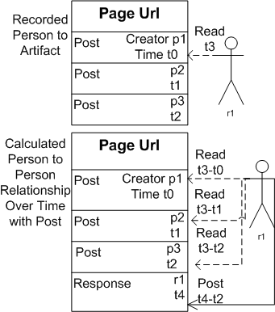

Figure - Conceptual view of the insert relational read events logic, with the top view showing what is originally recorded, and the bottom view showing what happens in the explosion

To understand how this fits with the rest of “Explode relational data”, a more detailed logical view is presented in figure 4.

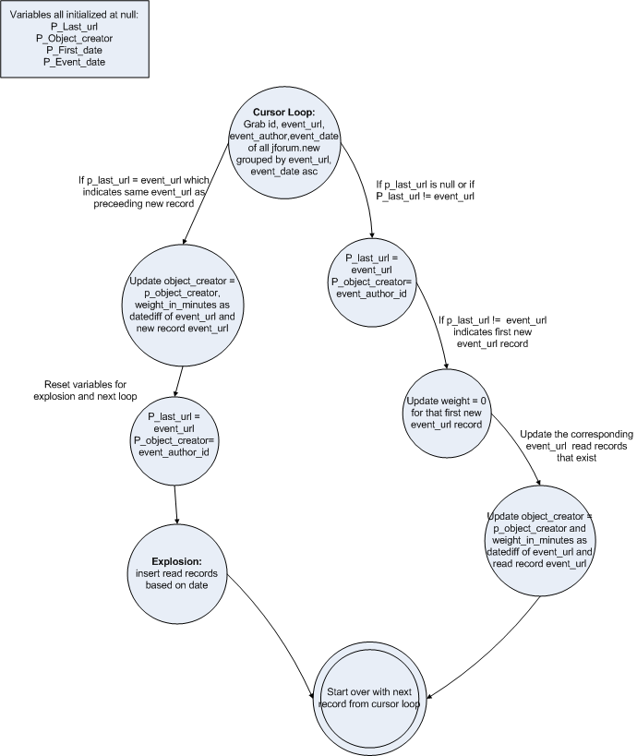

Figure - This is a detailed view of the "Explode Relational Data", including the "insert relational read events"; but it shows the steps in context with everything else involved in "Explode Relational Data"

The fourth step in “Explode Relational Data” is “Determine Read Row Type”. The purpose of this step is to provide metadata in the fact table, DW\_EVENT\_FACT, that shows us which rows were originally in the source data and which rows were added. This step is the same for either data input type (CANS or, the other current example, MyLyn).

The final step in “explode relational data” integrates the work of the previous steps to produce a single staging table with all exploded events and associated metadata. This is accomplished with the “insert\_events\_withcreators” procedure, noted in figure four. Also noted in figure two is the resulting table at the conclusion of this process, which is the “bd\_events” table.

## Create Dimension Records From Reference Tables

With BD\_EVENTS created, we are now ready to add rows, as necessary, to the dimension tables in the warehouse. The key dimensions are time, course module, context, actions, people and semester. Figure two illustrates the six procedures used to populate these dimensions. It is critical to note that, before populating new rows in the dimensions, the procedures check for existing rows with the same values. A seventh dimension for institution is hard coded. This seldom changes. For example, it is a single value for the CANS data, and also a single value for the MyLyn data.

## Create Final Fact Table

Rows are added to the “Final fact table”, DW\_EVENT\_FACT, by the procedure Dw\_insert\_events\_fact, which inserts one row per row in the BD\_EVENTS table, and creates a corresponding link with the dimensions. This results in a star schema, or “data mart”/”data warehouse” structure for events data that is optimized for analysis purposes. The key elements of the event fact, noted in figure two, are context, context type, event action, person – creator/author, time, weight in minutes, row type, module, semester and institution.

Since event fact

Table - Event Fact Data Description

|  |  |
| --- | --- |
| Event Fact Column | Description of Data |
| Context | Context is constituted by the context name, the context type and the events\_context\_id. In the MyLyn data, these elements are “Bugzilla”, “Software Engineering” and “MyLyn” respectively. In the CANS data, these elements are “Sakai”, “Group” and the course id (there are nearly 100). |
| Context Type | Software engineering, or “Group” What type of interaction context is this, exactly. |
| Event Action | The type of action. For now, this is “read” or “create”; jforum.read or jforum.new. |
| Person – Creator | Person who created the event record |
| Person – Author | Person who created the object the event record measures |
| Time | Timestamp of the event, which points to a time dimension, allowing for systematic temporal slicing of the data. |
| Weight in Minutes | Time distance from the previous event |
| Row Type | Whether the event row is from source data, or inferred from source data based on approximations of user behavior (i.e., in Sakai, a user is likely to view the five previous posts to some diminishing extent when reading or posting). |
| Module | Can be mapped to a module in a course, if this data is known. |
| Semester | Can be mapped based on the dates of the events. An imperfection in the current mapping of mylyn data is that we use the event\_session for release metadata. It would be more optimal to leverage the semester as a boundary for release.  This is something to explore in future releases. In the future, we may wish to connect institution id and semester in a single version of the fact table. |
| Institution | Hard coded. Currently the CANS host institution or “Drexel”, for the MyLyn data. |

# An example of full execution of the physical import process using data imported from the new, Oracle version of the CANS tables

The events from oracle are saved using MySQL Import from an Oracle Database restore. The table is events\_from\_oracle. It has the following structure:

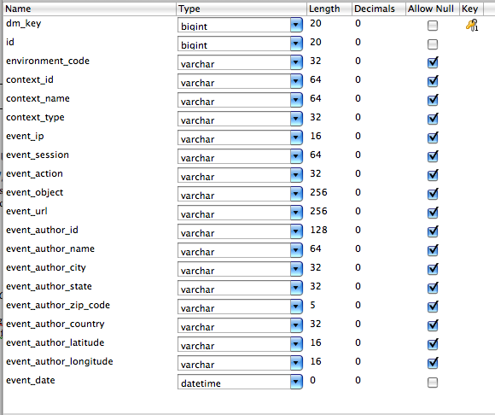

This structure mirrors the events structure in the current version of the CANS database. There is a significant flaw in the person data in the Oracle database for CANS: Some people have more than one unique event\_author\_id. This appears to be an artifact of an authentication conversion in the Sakai environment. We write the following SQL Script to map duplicates back to the shortest event\_author\_id string, which is the one most likely to exist in previous CANS data sets. Table six illustrates the SQL we used to correct this issue.

Table - Author Correction SQL

|  |
| --- |
| update events\_from\_oracle a, events\_from\_oracle b  set a.event\_author\_id = b.event\_author\_id  where a.event\_author\_name = b.event\_author\_name  and length(b.event\_author\_id) < length(a.event\_author\_id) |

## Following the Procedures

The next steps involve following a set of procedures that we have developed over the past year to import the data. Logically, those procedures are described above. The physical execution follows this precise path:

1. Execute clean\_events\_stage
2. Execute start\_to\_finish … which inside of itself, executes these procedures in sequence. During the execution, the cans\_warehouse.import\_status table is updated as each step is completed. In this way, if there is a failure, we have one place to go to evaluate the nature of that failure.
   1. Execute insert\_from\_events\_to\_events\_stage – this procedure has a line in it that specifies the table where your source data is in the **from** clause.
   2. Analyze Table – this makes sure the table has the right statistics, which is a performance enhancing step (a big performance enhancing step)
   3. Populate BD tables
      1. Execute Insert\_context\_type
      2. Execute insert\_context
      3. Execute insert\_event\_actions
      4. Execute insert\_person\_withcreators\_nonames
   4. Explode the data
      1. Execute insert\_into\_events\_stage – here, like in the case of MyLyn, you want to make sure you are using the correct version of the procedure. There is one version for source data that already has event\_creators, and another for data that does not have event\_creators
         1. Insert\_into\_events\_stage\_cans – no event creators
         2. Insert\_into\_events\_stage\_mylyn – with events creators
   5. Analyze events\_stage
   6. Update rows for SNA type
      1. Execute update\_rows\_for\_sna\_type
   7. Insert data into the BD\_Events table
      1. Execute insert\_events\_withcreators
   8. Execution scripts to add rows to dimensions as needed
      1. Execute DW\_insert\_context\_dim
      2. Execute dw\_insert\_time\_dim
      3. Execute dw\_insert\_event\_object\_dim
      4. Execute dw\_insert\_person\_dim\_sakai
      5. Execute dw\_insert\_events\_fact – there is an institutional id that might be updated for each set of data imported. For example, we called the oracle data from Mizzou “institution 3”; allowing for easier backup and identification of corpus origin within the data warehouse.

# UCern Mappings

## Input Data Structure & Data Map

Contained in the warehousemap.xlsx file in the directory.



## Explosions

1. The most important thing to understand about the uCern and Coffee Party data is that it reflects read only data, and this read only data requires a different explosion procedure: insert\_into\_events\_stage\_posts\_only
2. Everything else is the same.

# References

Goggins, S., Galyen, K., & Laffey, J. (2010). *Network Analysis of Trace Data for the Support of Group Work: Activity Patterns in a Completely Online Course*. Proceedings from ACM Group 2010, Sanibel Island, FL.

Goggins, S. P., Laffey, J., Amelung, C., & Gallagher, M. (2010). *Social Intelligence In Completely Online Groups*. Proceedings from IEEE International Conference on Social Computing, Minneapolis, MN.

Data Analysis From the Group Informatics LAB Interaction Warehouse

Table of Contents

Introduction 2

Step 0: Get Data Into the Standard Format 2

Input Data Structure 2

Data Map 2

SQL 3

Description of the MyLyn Map 5

Overview of CANS WAREHOUSE Data Flow and Transformation Processes 6

Extract Distinct Reference Points 6

Explode Relational Data 10

Create Dimension Records From Reference Tables 13

Create Final Fact Table 13

An example of full execution of the physical import process using data imported from the new, Oracle version of the CANS tables 14

Following the Procedures 15

UCern Mappings 16

Input Data Structure & Data Map 16

Explosions 17

References 18

Introduction 20

Trace Data Resolution Levels 20

Level 1 – Raw CANS Data 21

Level 2 – Bi-Directional CANS Data 23

Level 3 – Exploded Bi-Directional CANS Data 26

The Why and How of Exploding the Data? 26

Comparison of Network Analysis Using Level Two and Level Three Data 29

Level 4 – Weighted Extraction of Exploded Bi-Directional CANS Data 29

Online Course Data 30

MyLyn Data 30

An Example Analysis Process for Mylyn Data 31

References 31

# Introduction

Data analysis discussed here begins with data derived from Sean P. Goggins dissertation at the University of Missouri – Columbia. There are rich sets of data, which are described in some detail in two prior publications (Goggins, Laffey, Amelung, & Gallagher, 2010b; Goggins, Galyen, & Laffey, 2010a). We now have a wider array of data in the warehouse, but it is not as diverse methodologically as Goggins dissertation work. The data we have to work with is described in figure one.

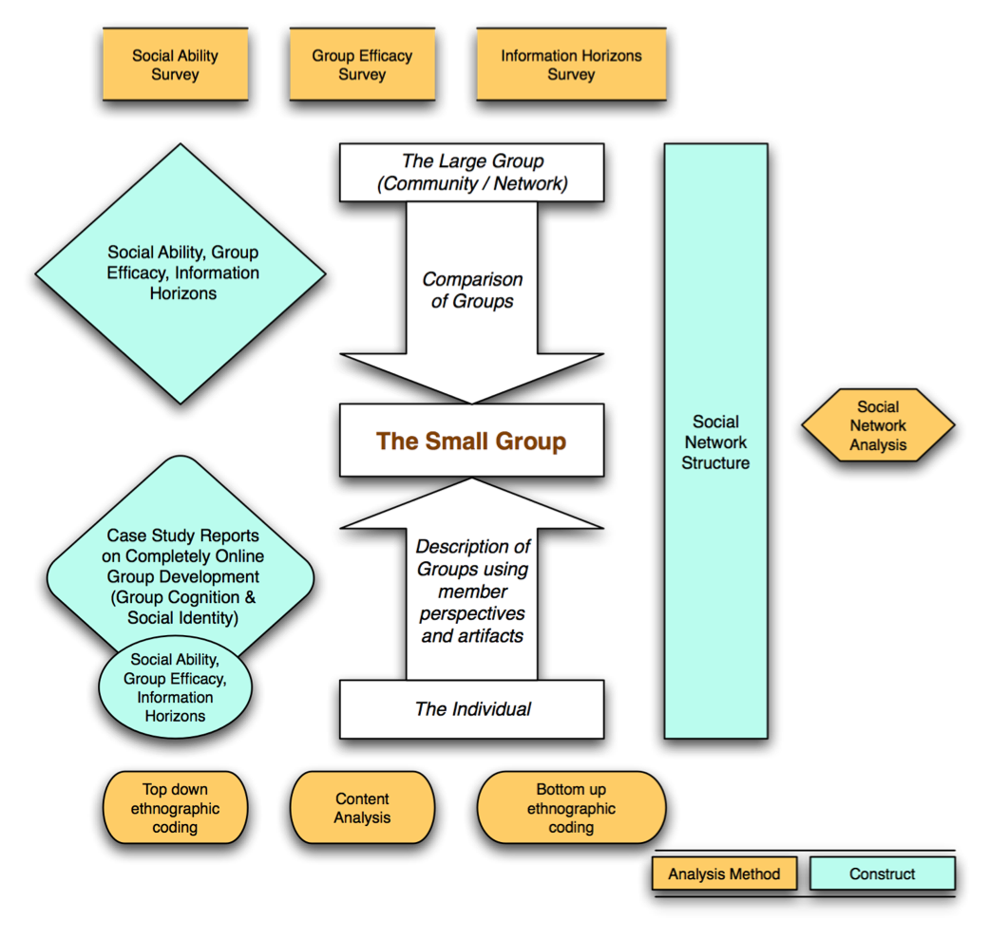

Figure - Data Richness is Sample Data Set

The trace data used in this analysis is possible because of the CANS system.

# Trace Data Resolution Levels

This data is trace data from the far right hand side of the diagram above. It is the network trace data we derive from the CANS system. We will walk through the data moving from its lowest resolution toward its highest resolution. In this case, by resolution we mean metadata richness. Table one enumerates this progression.

Table - Data Resolution Levels for CANS Data Analysis

|  |  |
| --- | --- |
| **Data Resolution Level** | **Data Resolution Level Description** |
| (1) Raw CANS Data | One event per row. We know what object (Discussion Board, primarily) the event is pointing toward, and what user created the event. We also know whether the event is a read or post event. |
| (2) Bi-Directional CANS Data | Most of the analysis reported by Goggins and his co-authors focus on this data set, because it indicates who is reading and posting in response to whom else. For example, if I read a discussion board topic that you created, then a connection is drawn between you and I. In addition to the data in “Raw CANS Data”, this data set contains:   1. Weight\_in\_minutes, which shows the distance in minutes between an event and the object (usually a discussion board) that event is in response to. 2. Object\_creator, which shows an anonymized identifier for the object creator. |
| (3) Exploded Bi-Directional CANS Data | Exploded Bi-Directional CANS data, as explained in Goggins, Laffey, Amelung & Gallager (2010b) and referenced in Goggins, Galyen and Laffey (2010a) recognizes the social form of online discussion to include recognition that when an individual participates in a discussion board in an online course, they attend to more recent posts in that discussion board. This data set adds rows that account for these to the data in the DW\_Event\_Fact table in the Interaction Warehouse. These rows are distinguished from the non-exploded data using the field row\_type:   * 0 = an original CANS event row * 1 = an exploded CANS event row |
| (4) Weighted Extraction of Exploded Bi-Directional CANS Data | This level incorporates findings from grounded theory coding of interviews that are part of Sean P. Goggins dissertation data corpus. Goggins found a consistent two day window of timestamp significance between events in CANS. Following a two day window, the likelihood that a post will be read or that the response is related to the discussion post that is more than two days in the past drops off significantly. This finding can now be applied recursively to the log data – something Goggins did not do as part of his dissertation work – to extract the most significant interactions (those within two days of each other) with a much greater weight than the least significant events. |

## Level 1 – Raw CANS Data

Raw CANS data shows us basic descriptive pictures, such as the overall degree of participation among members of an online course. We can see in figures xxxSG and xxxSG that one group, called “Get Along” group has the highest overall level of participation, in terms of total event count. Altogether, this group generated over 4,000 CANS events, with a single member of the group (Tommy), generating over 2000 as an individual. Looking at figure xxxSG and xxxSG together, it becomes clear that the group’s outlier status originates with Tommy. We can also notice here that Individualist Group member Justin is substantially lower in his overall participation; compared with everyone else. 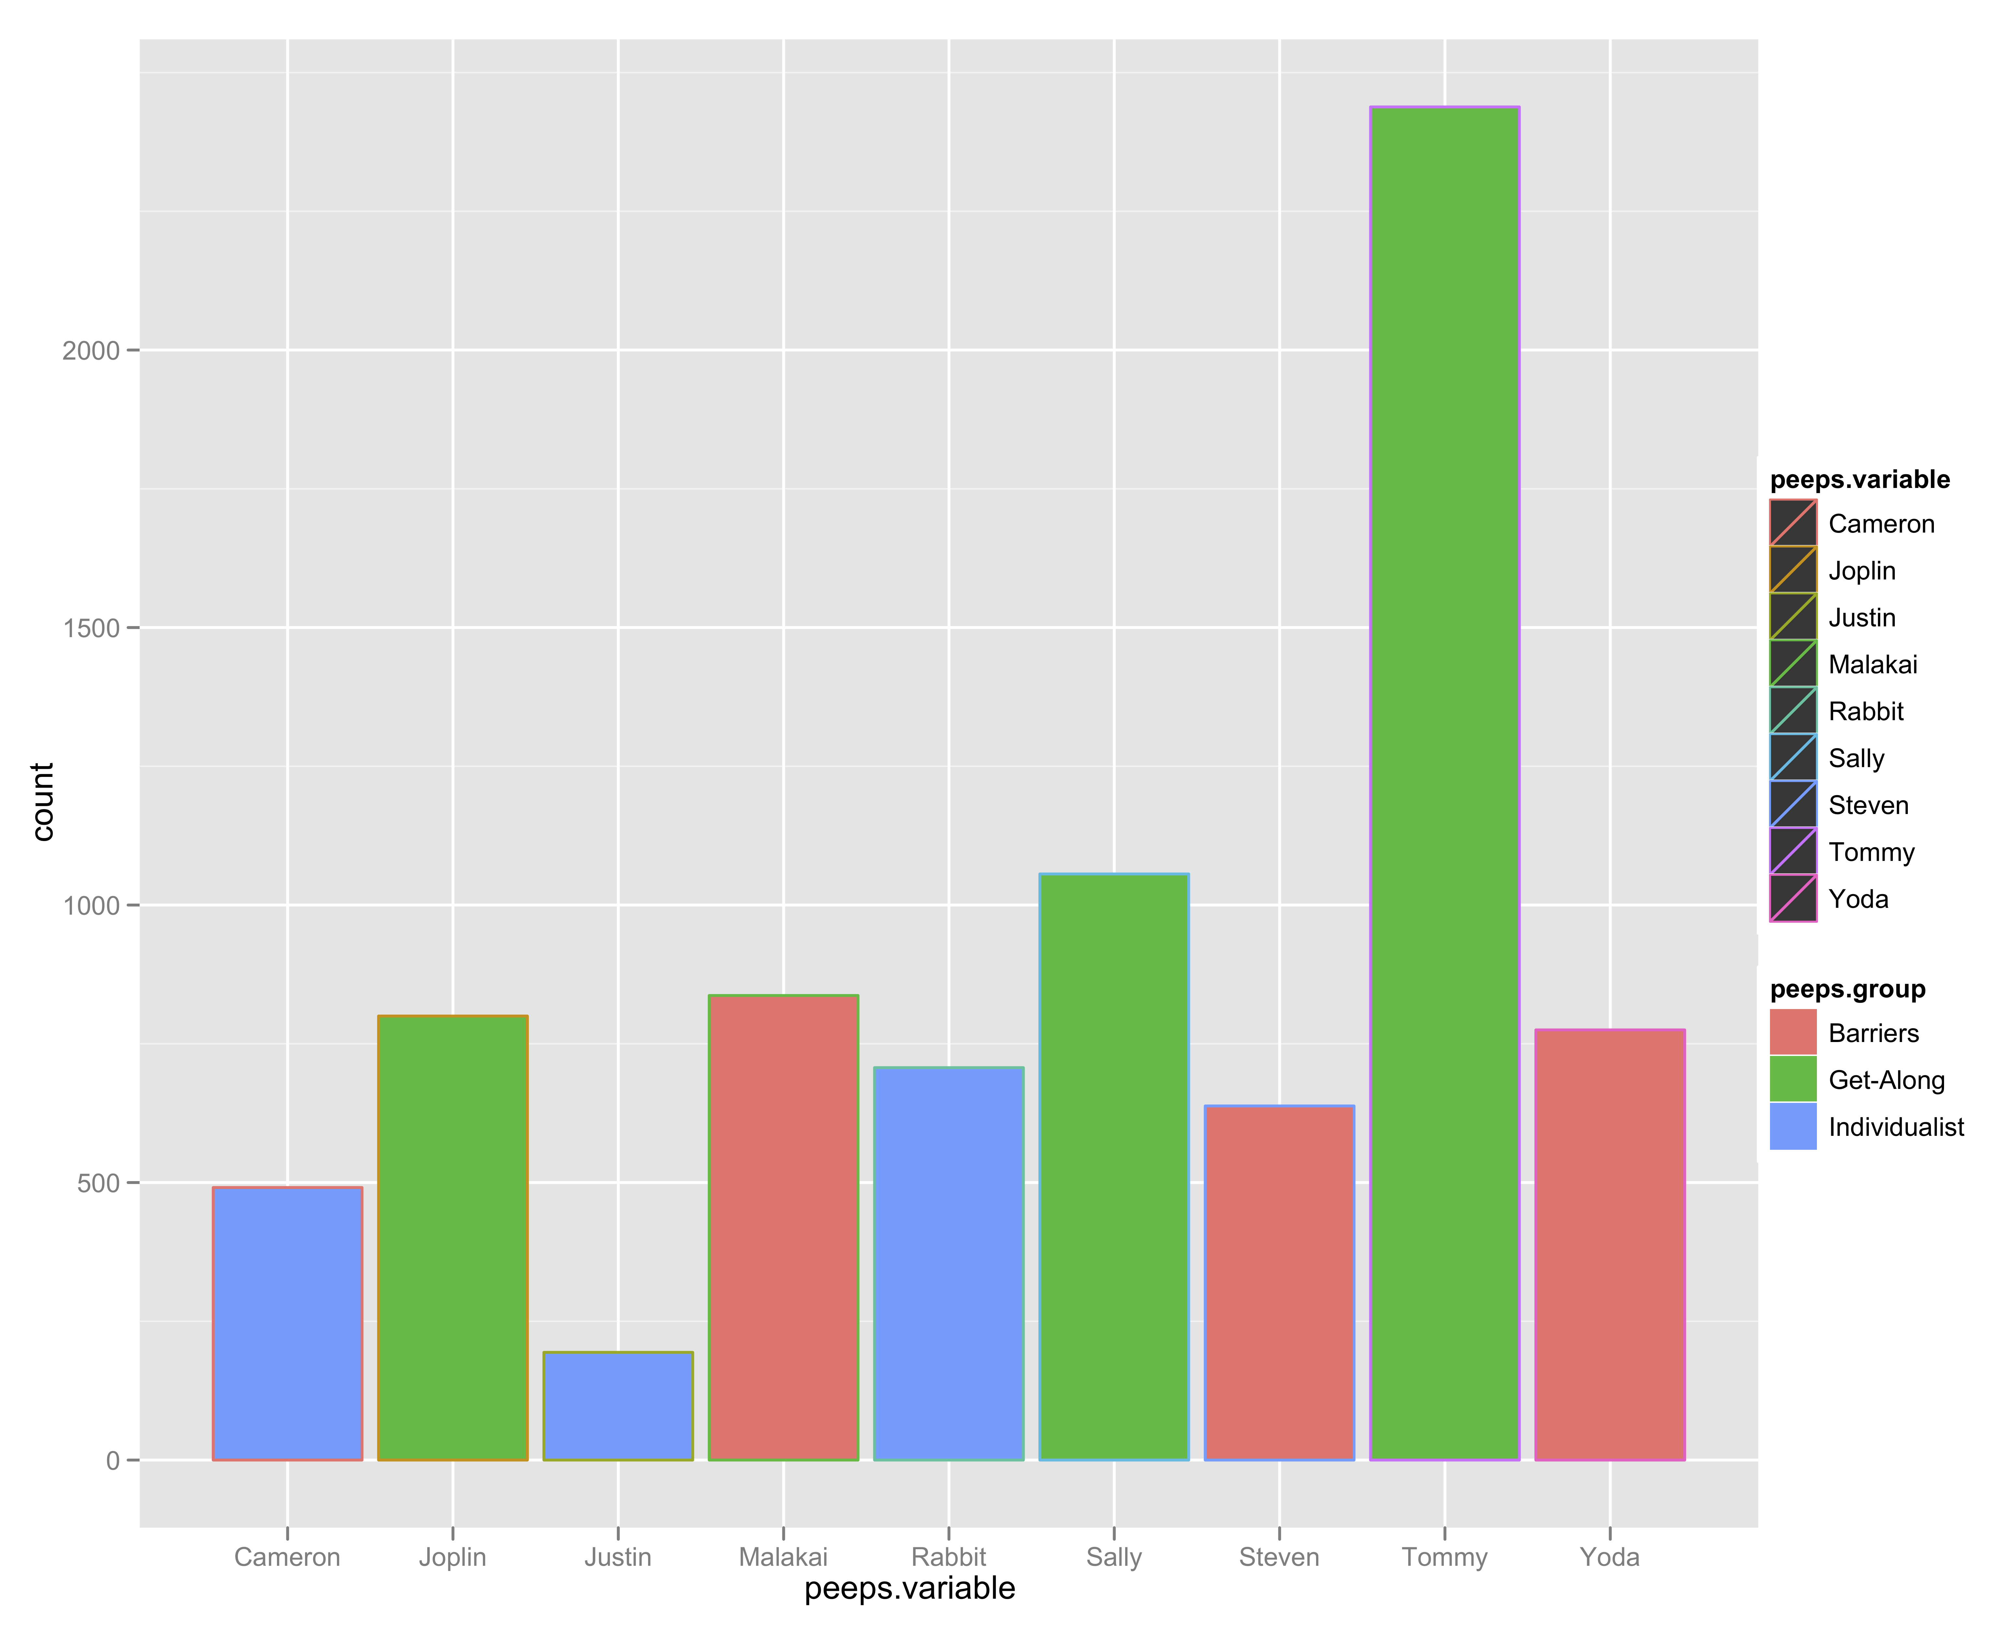

Figure - Total Participation by each member of three case study groups.

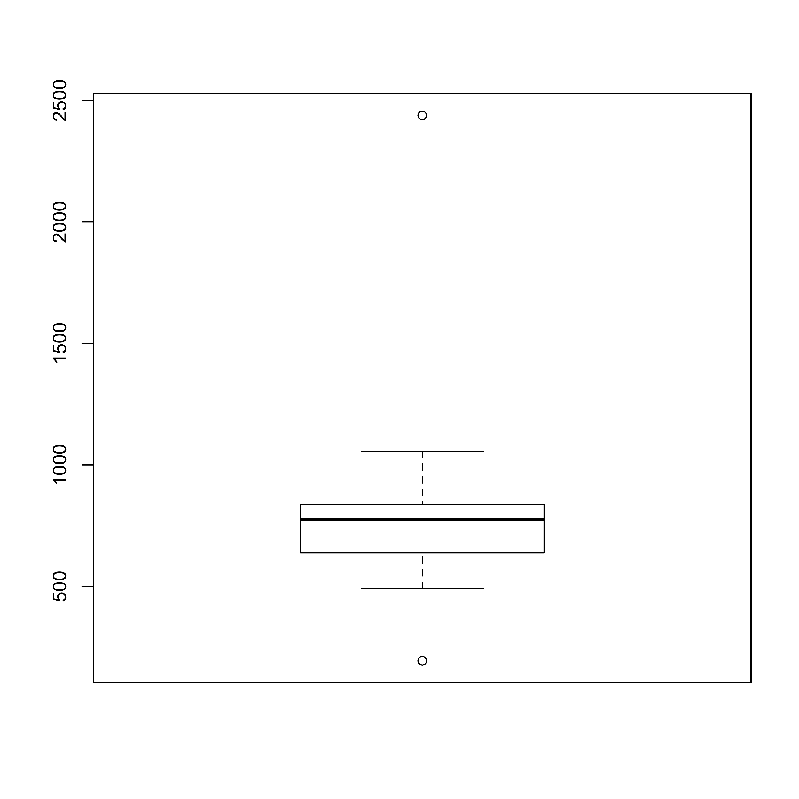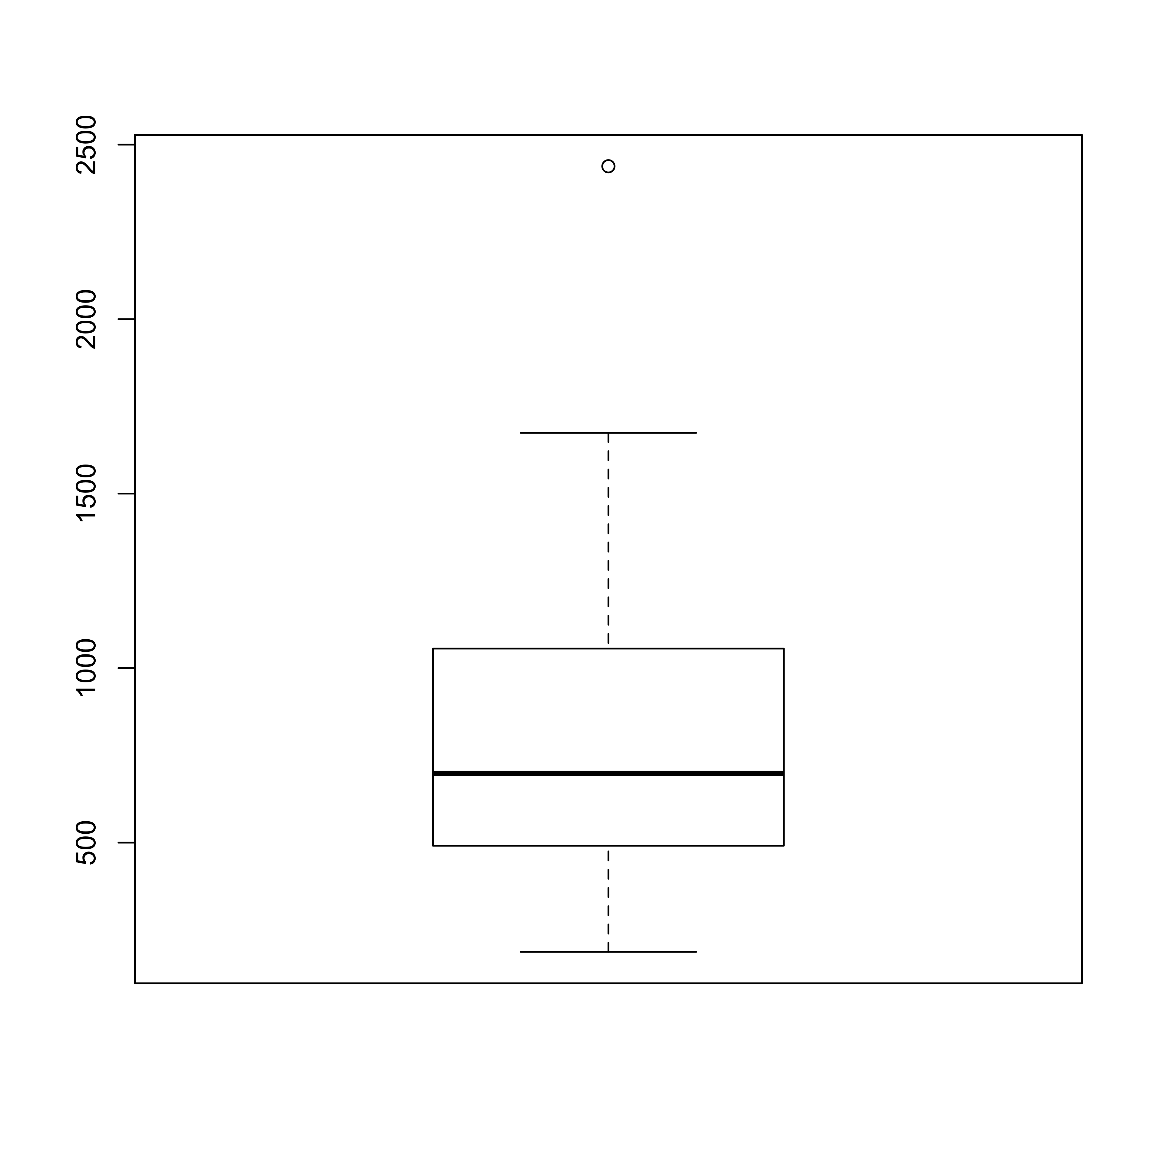

Figure - Boxplot of total event range in the three case study groups on the left, and for the whole course on the right. You can see that the case study groups fall into a narrower range of participation, on average, but the mean participation, symbolized by the black line in both plots, is similar. The case study groups are a good cross section of the course; though theoretically sampled for maximum contrast.

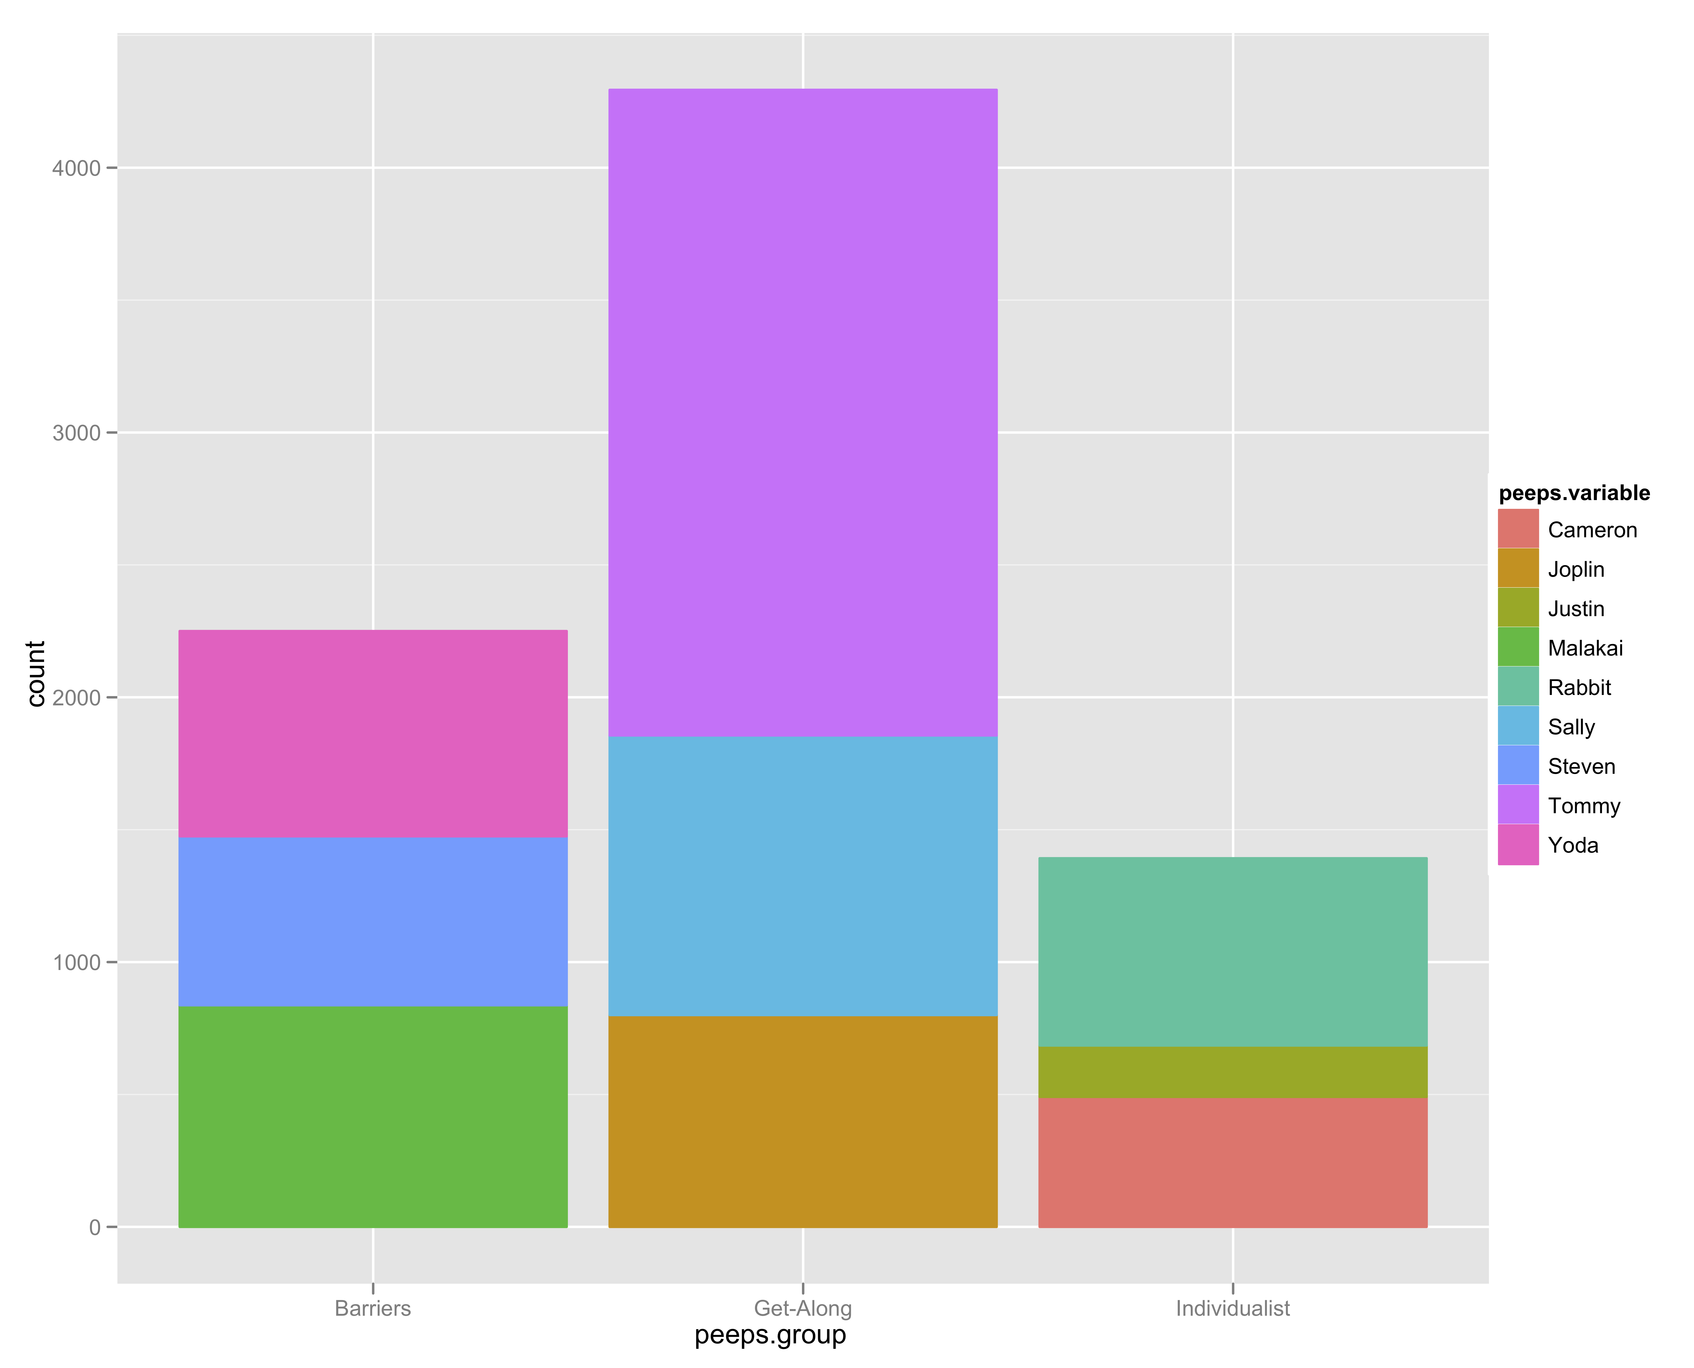

Figure - Total Participation by each member of three case study groups, stacked by group to compare total group activity.

## Level 2 – Bi-Directional CANS Data

With Bi-Directional CANS Data, there are a few things we can start to see right away by graphing weight\_in\_minutes. A cycle becomes apparent from these graphs of the raw, bi-directional CANS data. There is a slow and steady rise in the number of minutes between posts in the bi-directional data. This is because the basic measure of minutes for a discussion board is calculated using the formula: First Topic Post Timestamp (FTPT), and calculates the distance between those timestamps and the timestamp of the event. Often, there is a new discussion board for each module. So, the serial climbing of time distance between events and the posts they are originally responding to is logical. This is also the reason for exploding the bidirectional data. This effect is shown in figures xxxSG and xxxSG.

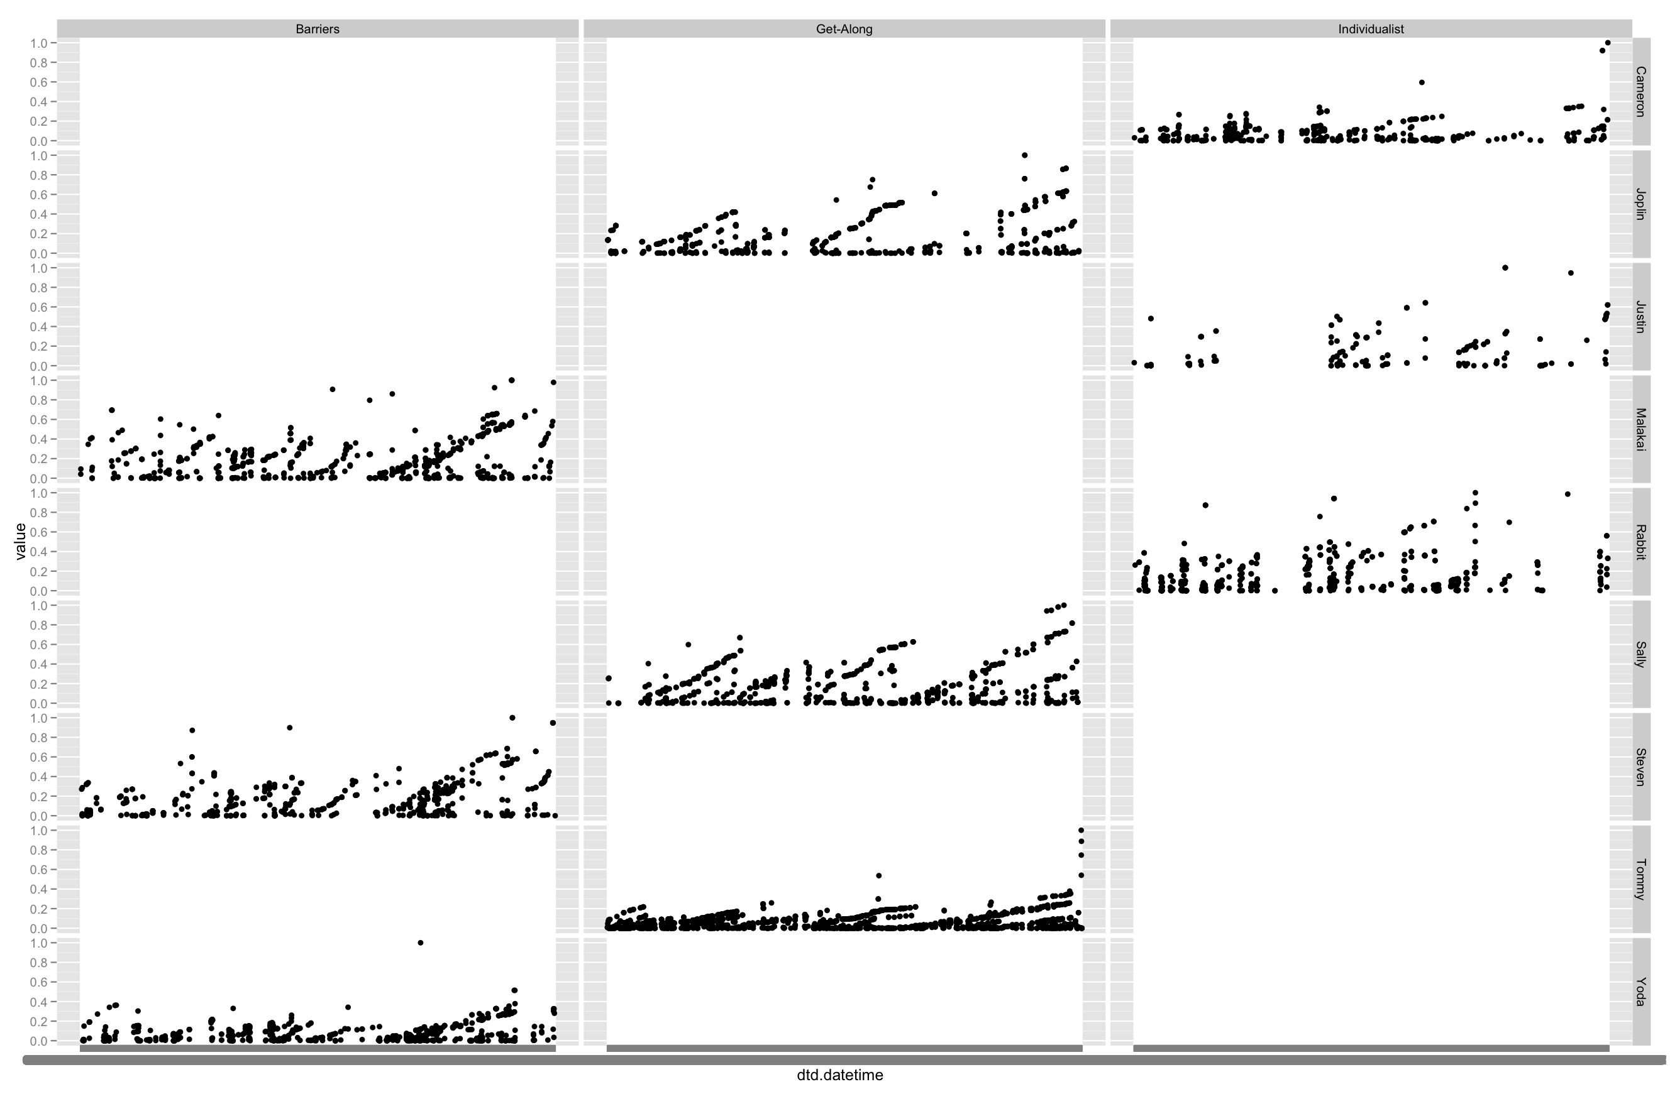

Figure – Weight (time distance) in Minutes for Three Case Study Groups Graphed Over Entire Course

The multi-panel view of the data shown in figure xxxSG reveals that the interaction pattern for Individualist Group is different than for Barriers or Get-Along Group; whose patterns of interaction are similar. This is less clear in the single panel view of figure xxxSG. The cycles for Individualist Group show that, instead of a steady climb during each module like we see for Barriers and Get-Along group, we see fairly fractured collaboration; there are many long breaks in the data for Justin and Rabbit. These breaks are consistent with other data we gathered, including interviews, field notes and surveys. The examination of this trace data, using this type of visualization, provides a clue about the differences in group development observed between the two groups.

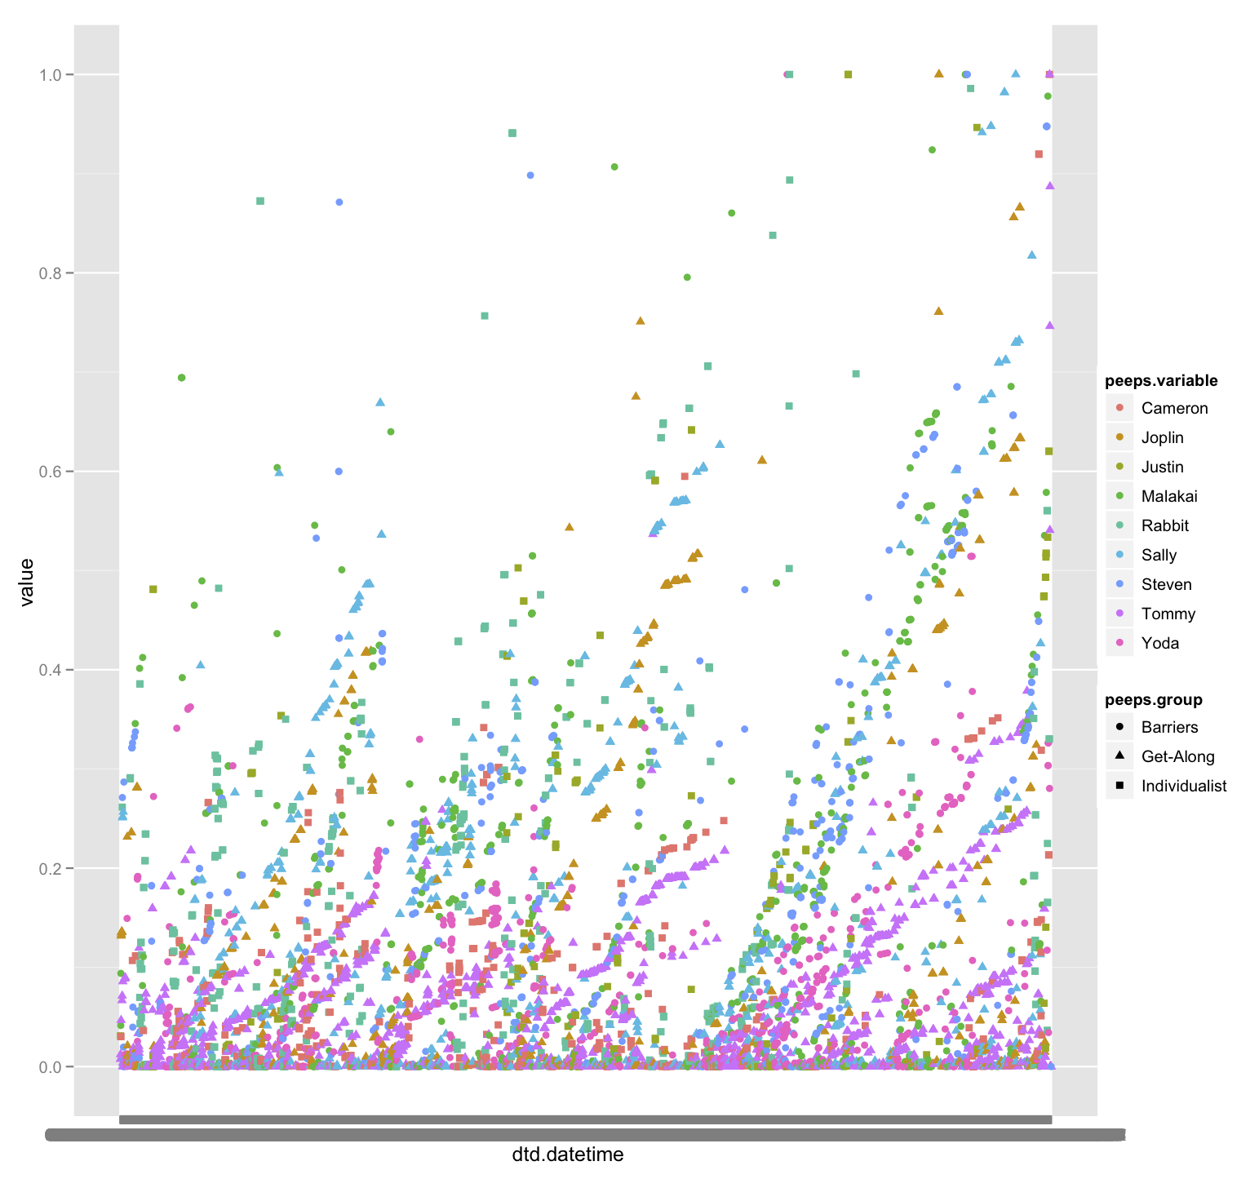

Figure - Weight in Minutes for Three Case Study Groups Graphed Over Entire Course (Single Pane View)

The different pattern of Individualist Group, which is visible in Figure five xxxSG, and less visible in figure six xxxSG. In figure seven xxxSG, the group trend is emphasized, and individual member behavior is not described. Figure seven xxxSG makes the irregularity of Individualist Group member participation visible, but less easily so than figure five. We present the additional figure here to compare and contrast the types of visualizations that might be useful when working with CANS data in different contexts.

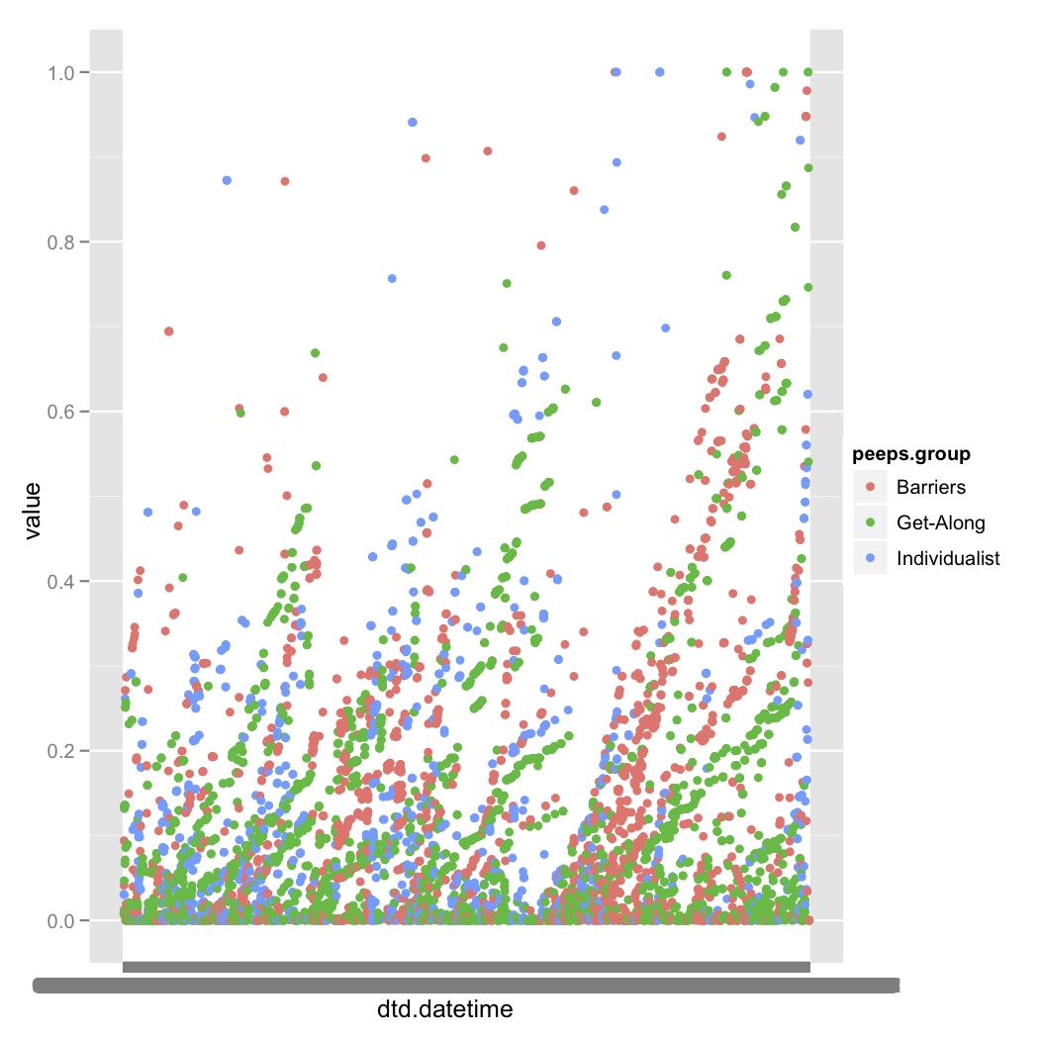[[1]](#footnote-1)Figure - Level 2 Group Trends and Cycles

## Level 3 – Exploded Bi-Directional CANS Data

### The Why and How of Exploding the Data?

When we “Explode” the bi-directional data, we create one row with a time weighted measure (in minutes) between each post in the discussion board, and each post that came before it. The structure of the discussion boards drives this calculation. In other systems, the human-human, human-information and human-computer interaction might be structured differently. The cyclical view we seen in figures xxxSG and xxxSG may not be present in MyLyn or VMT data, for example. How the explosion works is explained in Goggins, Laffey, Amelung & Gallager (2010b) and referenced in Goggins, Galyen and Laffey (2010a), and is illustrated in Figure xxxSG.



Figure - Mechanics of the explosion process

The data gets “blown up” because in this format we are able to perform more complete social network analysis than we could perform with the Level 2 bi-directional CANS data. Social network analysis was used to address our first research question, which is how and to what extent interactions and group structure vary by activity type. Our interaction analysis was guided by structural theories of social organization [3,6,18], and constructed from CANS data. Individual actions (reads, posts and responses), which occur mostly (92% of events) in the discussion board, are the core data that define network structure in our analysis. The discussion board we use is of the type where up to five posts are viewable on a page. If “reader 1” views a page in a discussion thread, a network “read” tie is created between that person and each person who has previously posted content to that page. Figure one describes this, with p1..pn being a “poster”, and t1.. tn being a timestamp. Read actions in other parts of Sakai (8% of events) require a “click” and are recorded as each event occurs.

When we explode the data, we expect the basic shapes of activity count (participation) from Level 2 to remain. We are simply adding implicit connections from the discussion board. For example, Justin has the lowest participation and Tommy the highest participation at both Level 2 and Level 3. Figures ten and eleven xxxSG both demonstrate that the shapes for total participation are uninfluenced by the explosion of the data to meet discussion board needs.

:plots:Exploded Data - Level 3:RPlot of the CASE Study Groups.pdf

Figure - - Total Participation by each member of three case study groups (with exploded data)

The Data at Level Three does not change at a summary level like we have presented here, but it does create a fuller picture of the interactions that occur, both passively (reading) and actively (posting) between all members of an online course. Without the explosion, out network analysis would be limited by the relationship between an event and the event either immediately preceding it, or the event that initiated the conversation thread. Either choice mutes the true nature of the group structure that develops in a completely online course.

:plots:Exploded Data - Level 3:RPlot of the CASE Study Groups - GROUP Stacked.pdf

Figure - Total Participation by each member of three case study groups, stacked by groups to show total contrast. (Using Exploded Data).

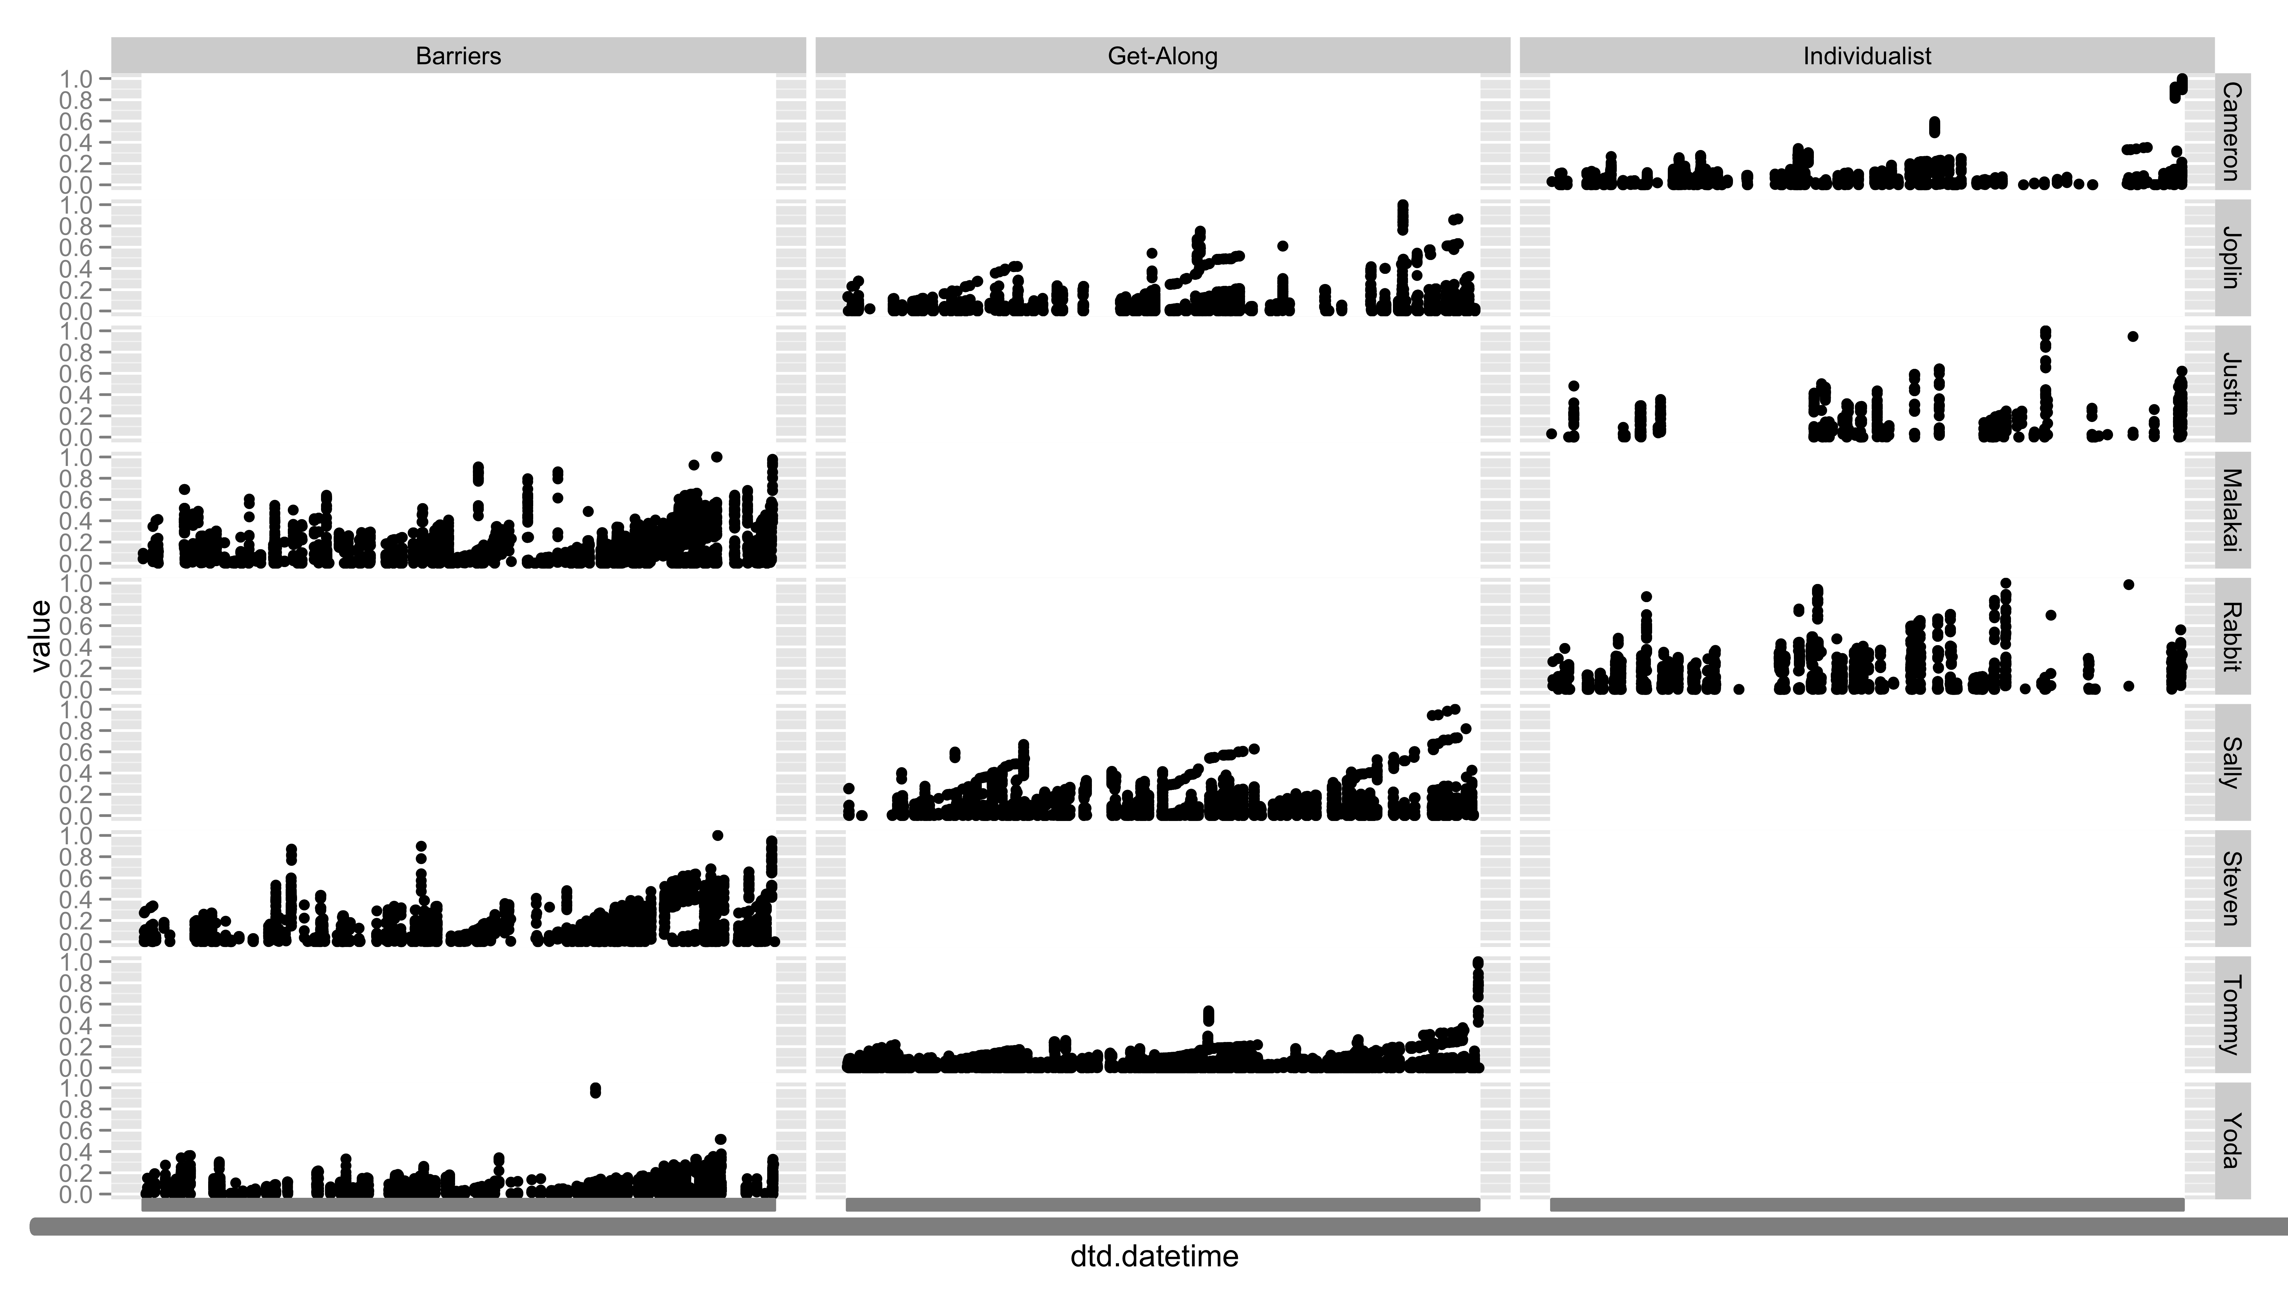

Figure - Basic Shapes of Jitter Plots Remain Consistent from Level 2 to Level 3

## Comparison of Network Analysis Using Level Two and Level Three Data

## Level 4 – Weighted Extraction of Exploded Bi-Directional CANS Data

There are differences in how the weighted extraction occurs in different source data sets. This is because the weights are semantically different. Response cycles in an online course are predictable and follow a rhythm. Bug response data, in contrast, follows a different rhythm. We will provide examples of how we conceptually and physically extract data from two different projects – the case study of a completely online course, which we have discussed exclusively to this point; and the MyLyn open source project, which represents a second set of important online data.

### Online Course Data

### MyLyn Data

When we analyze Mylyn data, time is experienced differently. There are not the firm deadlines, begin times or end times that occur in an online class. In this case, visualizing data over the course of years is important. Here, we look at five different bugs, and when the most conversational activity occurred around those bugs. in order from bottom to top, the bugs are:

1. d
2. d

Weight, however, exists in a conceptually similar way. The calculations of weight for the MyLyn data reflect a time distance that is more linear; with more time passing between communication serving as an indication that the intensity of back and forth conversation is low; and on a per bug, relative scale, the most heavily weighted (shortest time distance) communication is likely to occur as people solve problems related to the bugs. This pattern is shown in figures 12 and 13 (xxxSG).

:::61.  Mylyn Data:TimeSeriesAnalysis:qplot-release-weight-faceted_bug-year.pdf

Figure - Five most active bugs by year of activity

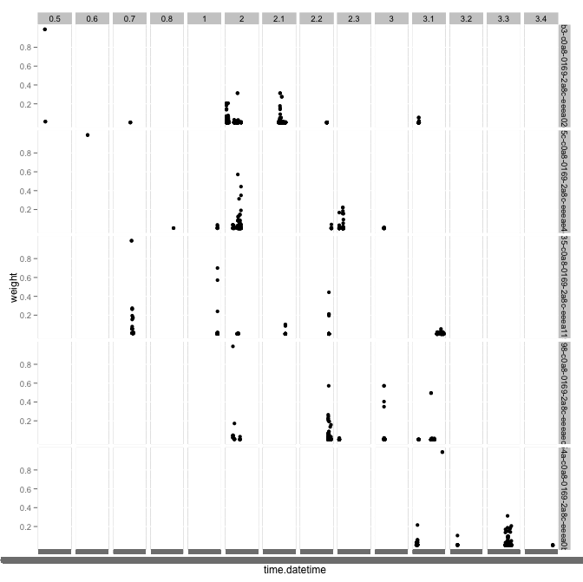

Figure - Incorporating Release and Time

## An Example Analysis Process for Mylyn Data

To extract Mylyn Data, there are a number of steps we follow, depending on the specific data. For network analytic data, we have a MySQL stored procedure that will pull data for all of the releases. Simply execute the following command: call cans\_warehouse.research\_mylyn\_release\_extract\_driver from a database prompt in the CANS\_WAREHOUSE database.

# References

Goggins, S., Galyen, K., & Laffey, J. (2010a). *Network Analysis of Trace Data for the Support of Group Work: Activity Patterns in a Completely Online Course*. Proceedings from ACM Group 2010, Sanibel Island, FL.

Goggins, S. P., Laffey, J., Amelung, C., & Gallagher, M. (2010b). *Social Intelligence In Completely Online Groups*. Proceedings from IEEE International Conference on Social Computing, Minneapolis, MN.

1. The initial explosion creates a “Time distance weight”, which means that the visualizations in this section and the one prior are inverted, compared with Level 4 network graphs, described later. [↑](#footnote-ref-1)